PROJECT REPORT

Project Title:
Estimation and Prediction of Hospitalization and Medical Care Costs.
Team ID: LTVIP2023TMID00385
Team Size: 5
Team Leader: BODDANA LIKITHA
Team Member: POTIPIREDDI BALA SANYASAMMA Team Member: BOMMANAMOUNIKA
Team Member: MAVURI BHUMIKA
Team Member: OMMI BHAVANI
Faculty Mentor: P.S.KIRAN KUMAR

INTRODUCTION

  - OVERVIEW

Medical costs are one of the most common recurring expense
in a person's life. Based on different research studies, BMI, ageing,
smoking, and other factors are all related to greater personal medical
care costs. The estimates of the expenditures of health care related
to obesity are needed to help create cost-effective obesity prevention
strategies. Obesity prevention at a .Young age is a top concern in
global health, clinical practice, and public health.

Data Collection and Preprocessing:
A comprehensive dataset was collected from kaggle
Which includes age, sex, region, charges, smoker, BMI.
The collected data underwent thorough preprocessing to handle missing values, remove inconsistencies, and ensure data quality.

Exploratory Data Analysis (EDA):
EDA was conducted to gain a deep understanding of the dataset. Visualizations and summary statistics helped in understanding the characteristics of the data and guided further analysis.

Creating a Flask web application:
For Estimation and Prediction of Hospitalization and Medical Care Costs data involves building an interface where We can input relevant information, and the application will use the predictive model to estimate the medical care costs.

PURPOSE
The Estimation and Prediction of Hospitalization and Medical Care Costs project plays a vital role in data- driven decision-making, cost optimization, and improving patient care in the healthcare industry. It empowers various stakeholders with actionable insights to make informed choices and enhance the overall efficiency of the healthcare system.
By undertaking the Estimation and Prediction of Hospitalization and Medical Care Costs project, several significant achievements and benefits can be realized in the healthcare industry and beyond.

KEY OUTCOMES:
- Cost Optimization
- Improved Financial Planning
- Transparency and Informed Decision-making
- Enhanced Patient Care
- Tailored Insurance Coverage

LITERATURE SURVEY:
The prevalence of obesity, which is defined as a body mass index (BMI) greater than 30, has increased dramatically in the United States since the late 1990s.
So much so that recently obesity has been officially recognized as a disease by the American Medical Association, an action that could put more emphasis on the health condition by doctors and insurance companies to minimize its adverse effects. Currently, rates of obesity exceed 30% in most sex and adult age groups, whereas its prevalence among children and adolescents, defined as a BMI of more than the 95th percentile, has reached 17%.
The alarming rates of the high prevalence of obesity have posed a significant public health concern as well as a substantial financial burden on our society because obesity is known to be a risk factor for many chronic diseases, such as type 2 diabetes, myocardial infarction, cancer, hypertension, asthma, stroke and other conditions.
To understand the economic burden of obesity, several studies have attempted to estimate the attributable costs of obesity, following the burden-of-illness literature on other disease areas. A previous cost-of-illness study estimated that healthcare spending attributable to the rising prevalence of obesity has increased by 27% between 1987 and 2001.

Existing problem:
Solving the Estimation and Prediction of Hospitalization and Medical Care Costs involves a systematic approach that combines data analysis, model development and evaluation.

Proposed Solution
Proposing a solution for the estimation and prediction of hospitalization and medical care costs involves a combination of data-driven techniques, advanced analytics, and domain expertise. Collect comprehensive and diverse data related to hospitalization and medical care costs from various sources, including electronic health records, insurance claims, and administrative databases. The success of the proposed solution depends
on the availability of quality data, collaboration with healthcare experts, and a commitment to continuous improvement based on real-world feedback. Healthcare cost estimation and prediction are complex tasks, and a multidisciplinary approach is crucial for achieving accurate and reliable results.

THEORITICAL ANALYSIS
  - Block Diagram
Creating a detailed block diagram for Estimation and Prediction of Hospitalization and Medical Care Costs involves breaking down the process into key steps and components. Below is a high-level block diagram outlining the main stages and elements involved in estimating and predicting hospitalization and medical care costs.
The block diagram illustrates the end-to-end process of estimating and predicting hospitalization and medical care costs, starting from data collection and preprocessing to deploying the final models for cost estimation and future cost prediction.



















    - LITERATURE SURVEY
    - SOCIAL OR BUSINESS IMPACT
    - SPECIFY THE BUSINESS PROBLEM
    - BUSINESS REQUIREMENTS

DOWNLOADED DATSET FROM KAGGLE

LOGGED INTO IBM COGNOS ANALYTICS AND CREATED DATA MODULE

CREATED SEVERAL UNIQUE VISUALIZATIONS

CREATED MEDICAL CARE COSTS DASHBOARD

GUIDED JOURNEY SLIDESHOW

VISUALIZATIONS WITH DETAILED INFO

DASHBOARD, REPORT, STORY WAS DEPLOYED INTO UI WITH FLASK

SOFTWARE OR HARDWARE DESIGNING Software Requirements:
- IBM cognos analytics Tool
- Flask
- Integrated Development Environment (IDE)-Spyder

Hardware Requirements:
- Minimum System Requirements(RAM-4GB,Quad core Processor Or above).

RESULT
DATA VISUALIZATIONS:

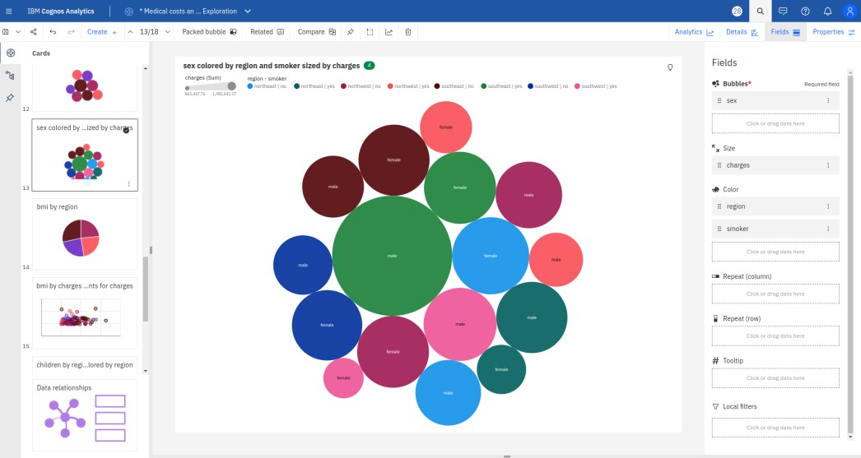
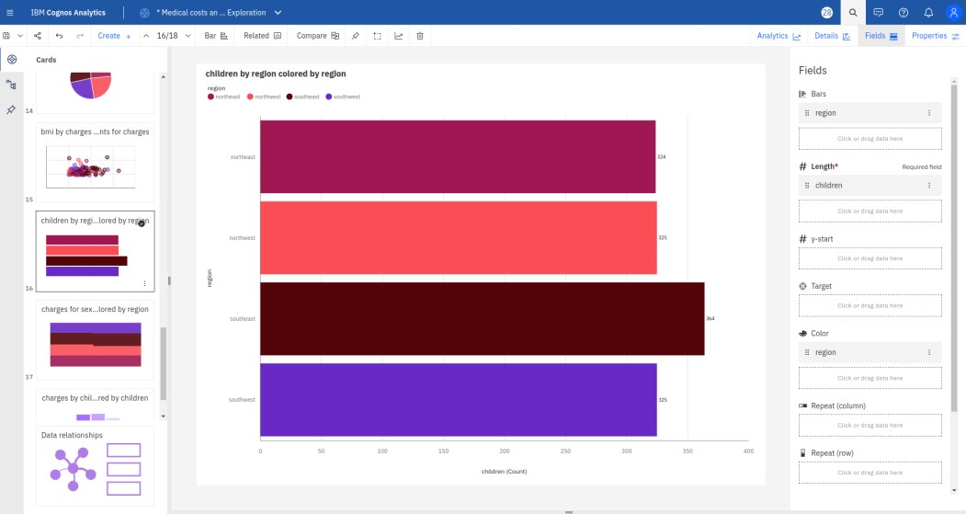

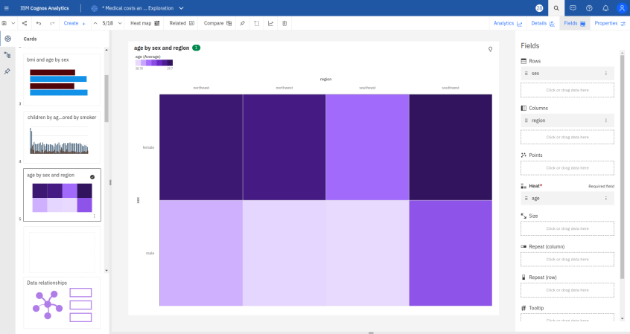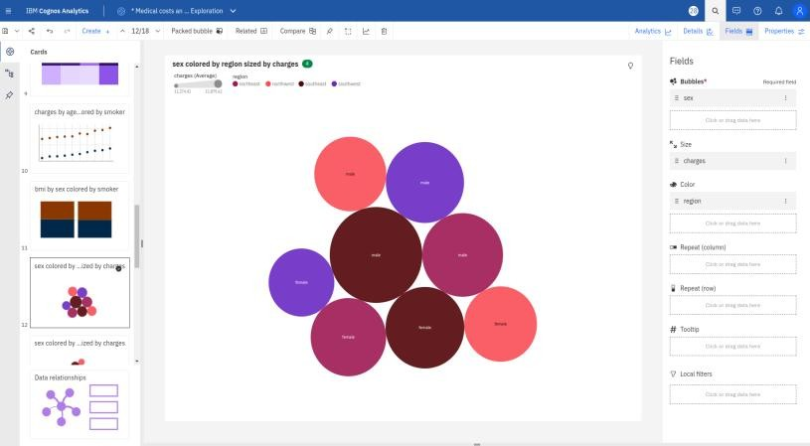

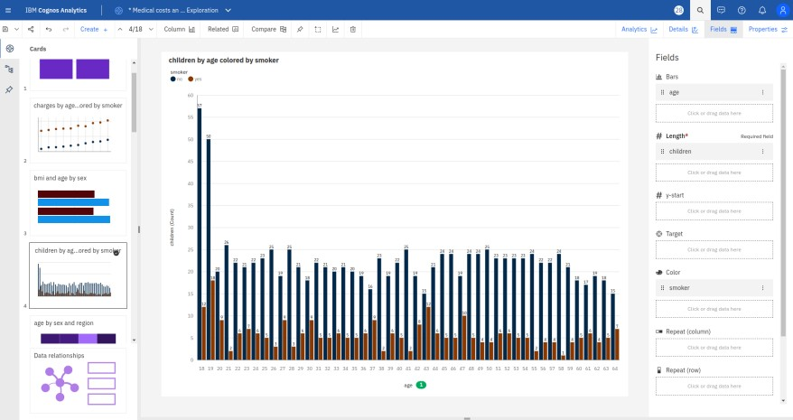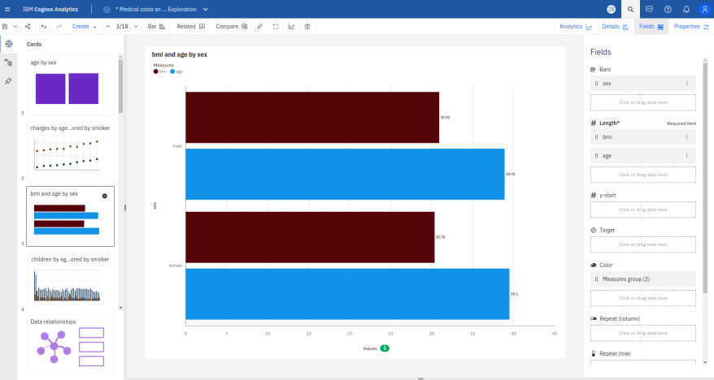
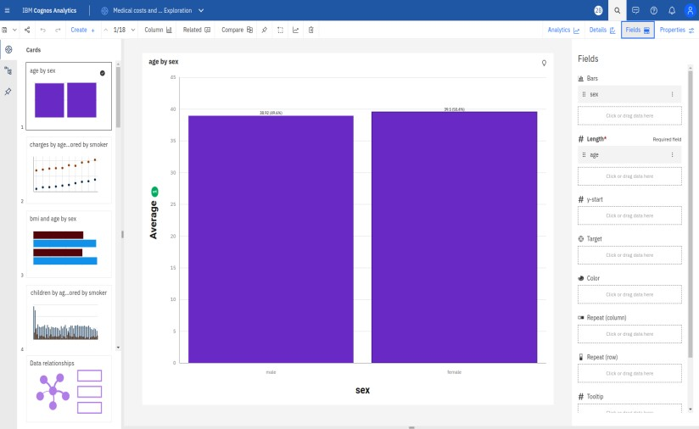
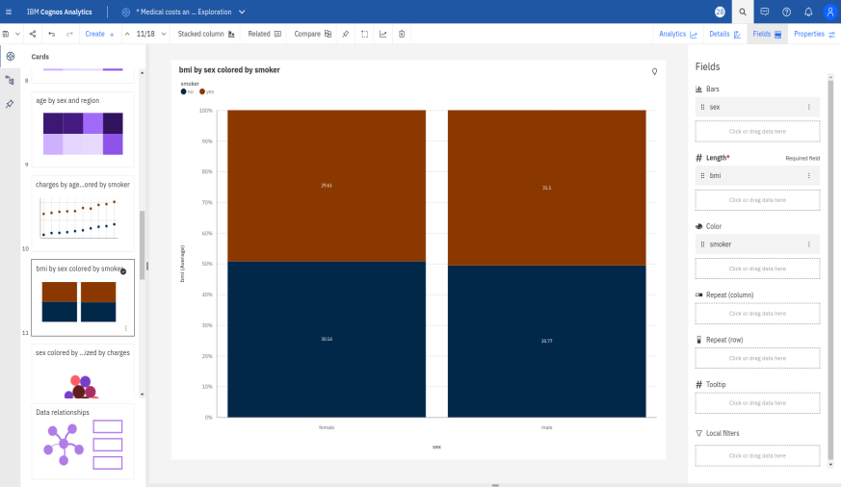
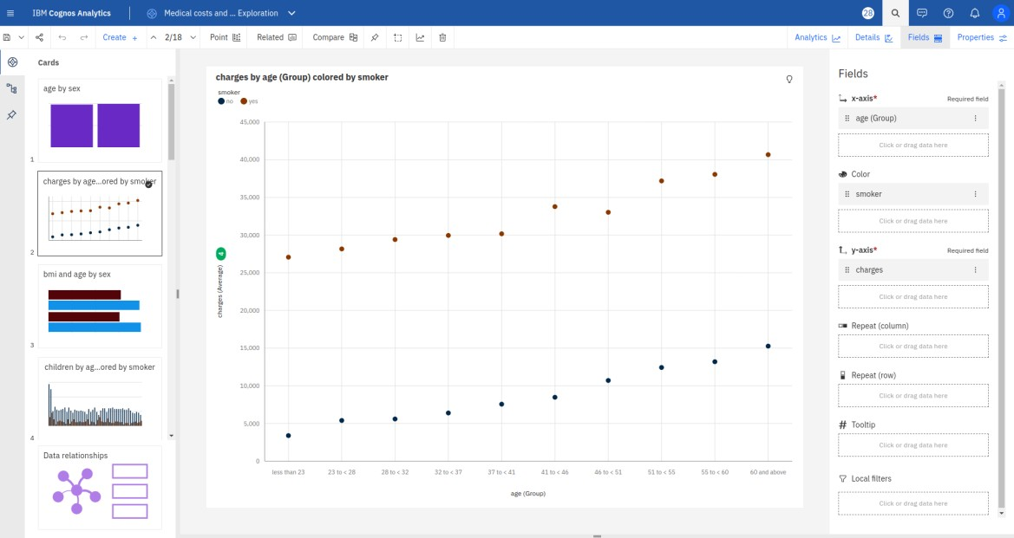

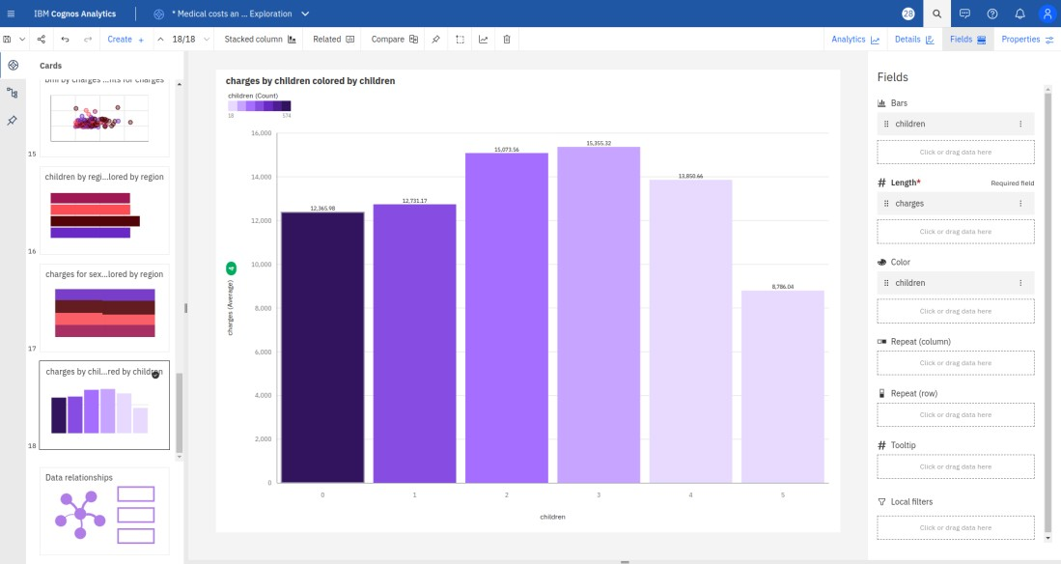
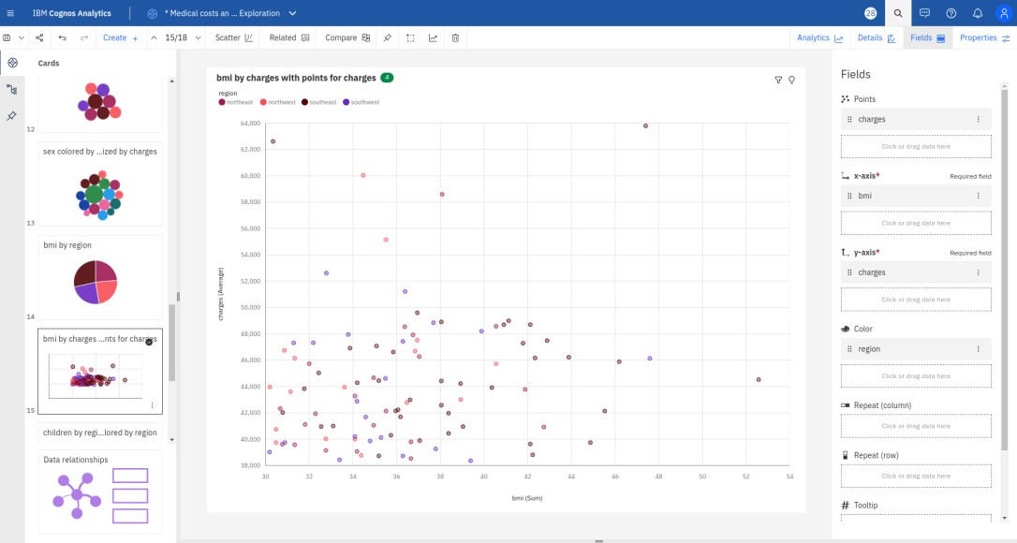

MEDICAL CARE COSTS DASHBOARD
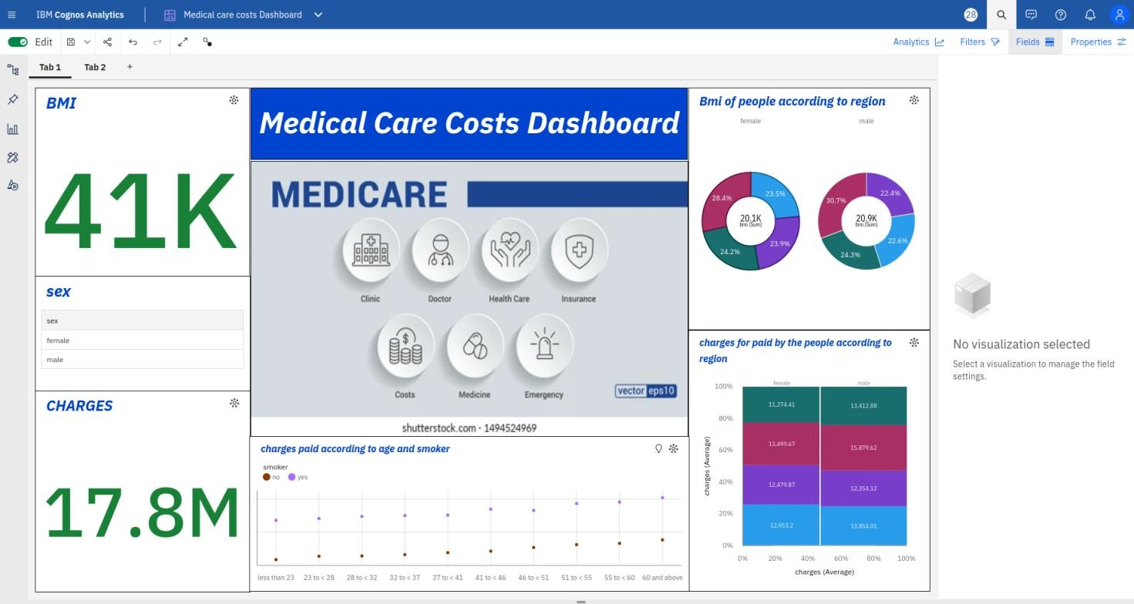
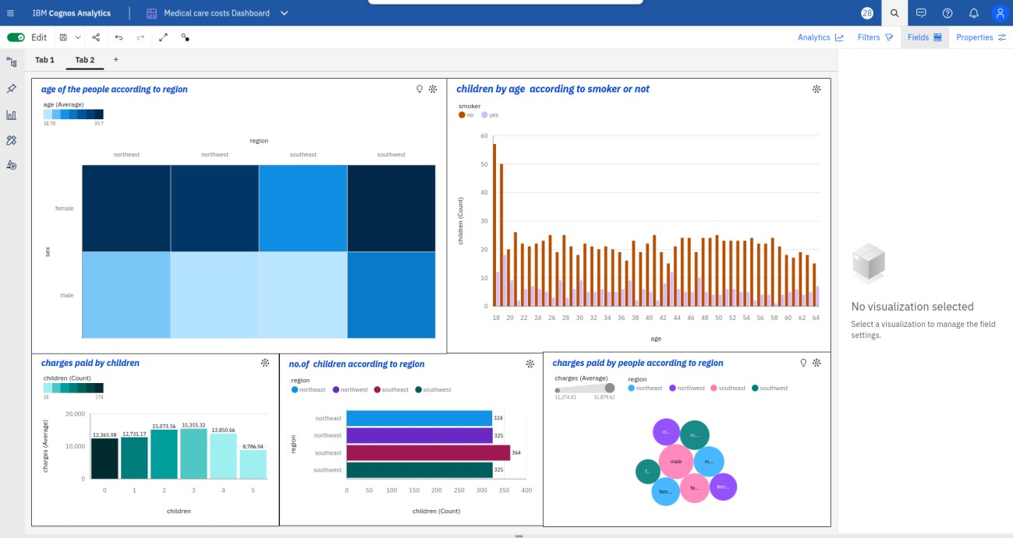

REPORT(PAGE 1):

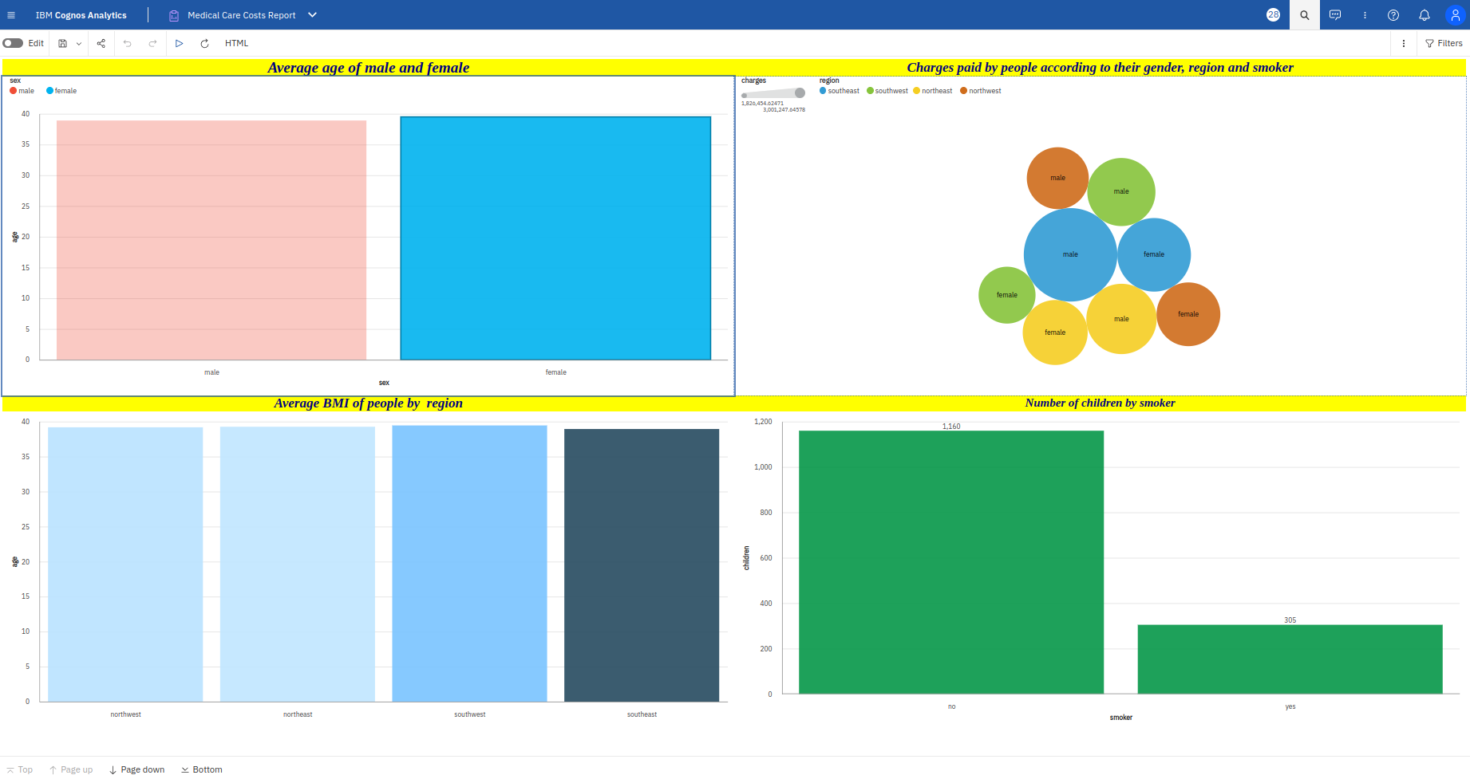

PAGE 2:
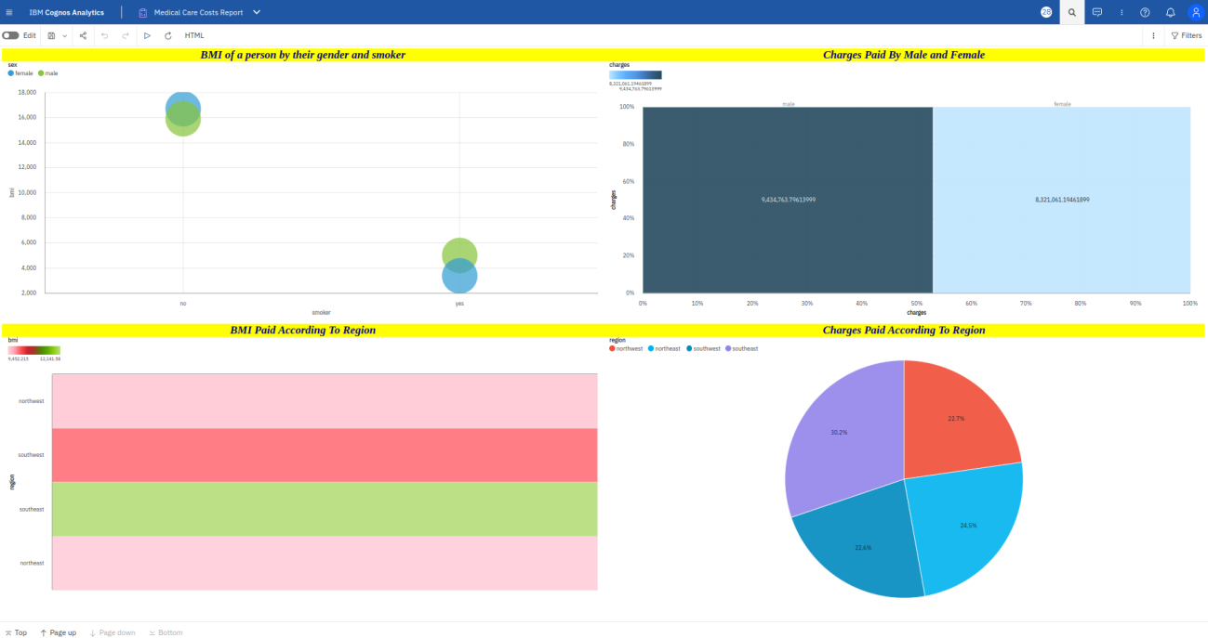

STORY(GUIDED JOURNEY):

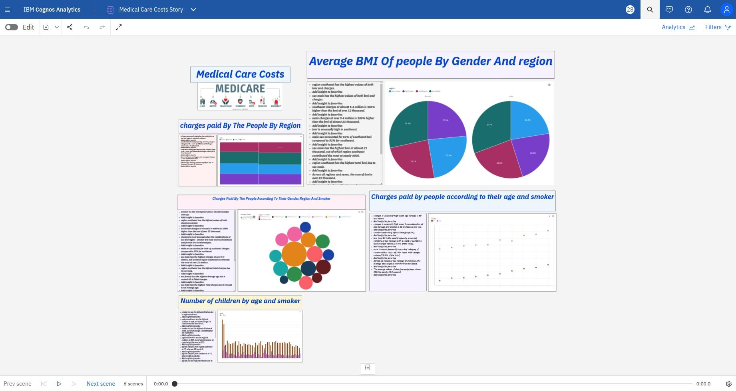

STORY(SLIDESHOW):

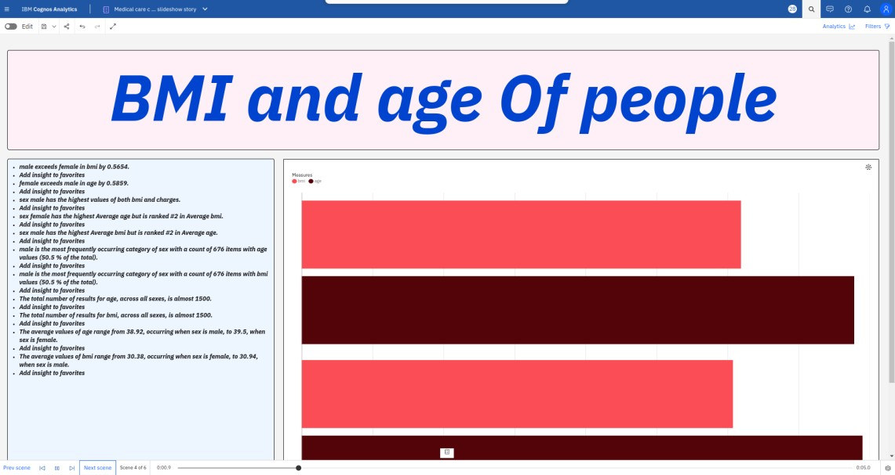
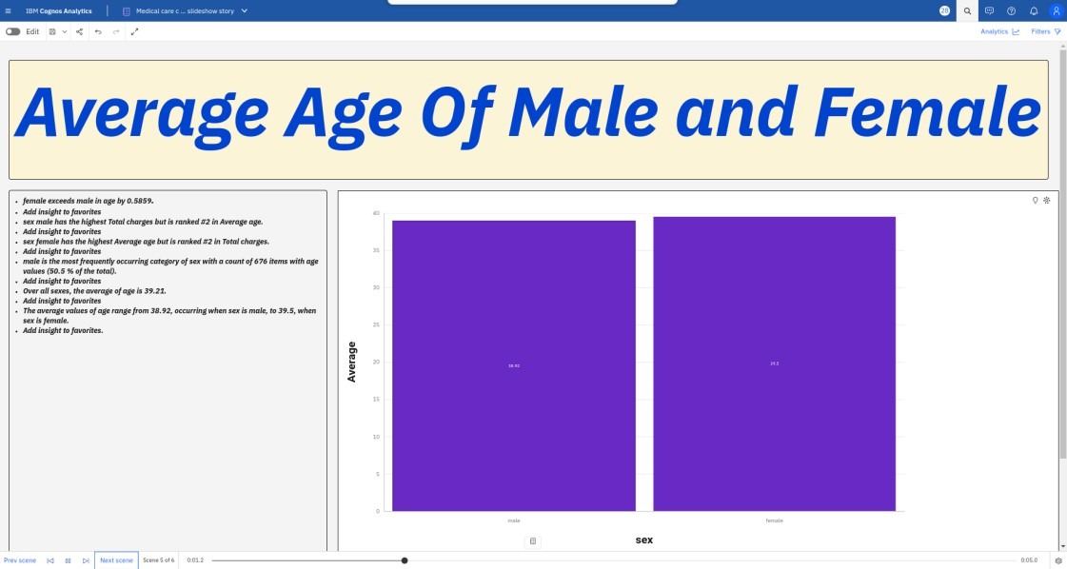
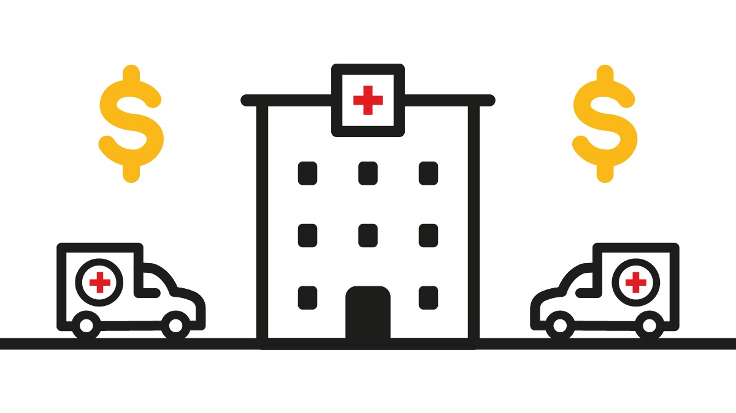
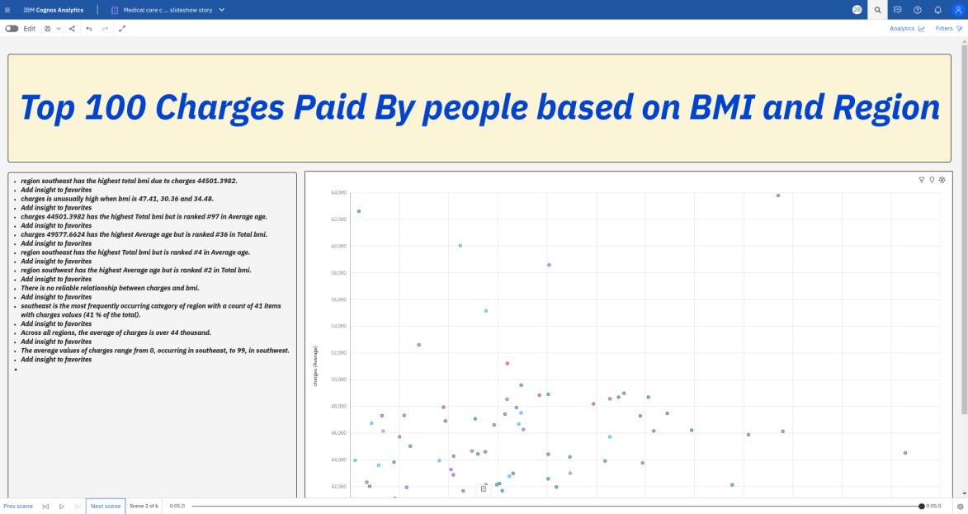
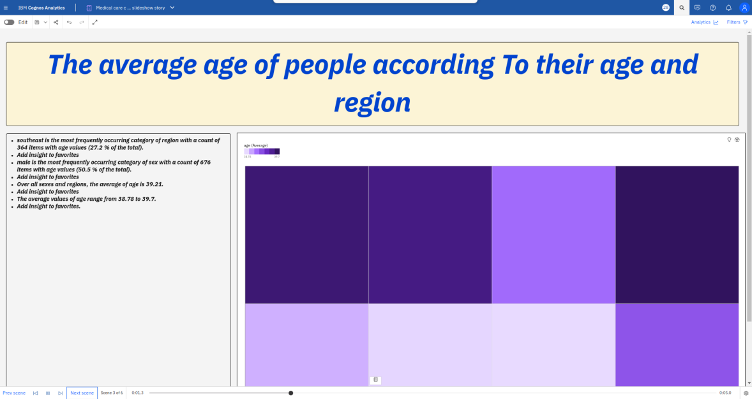

WEB INTEGRATION:

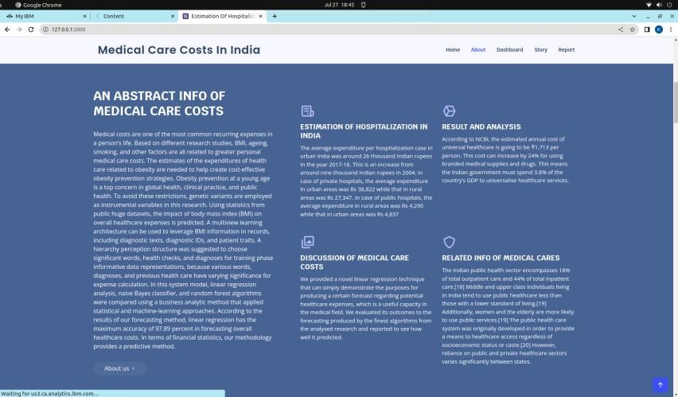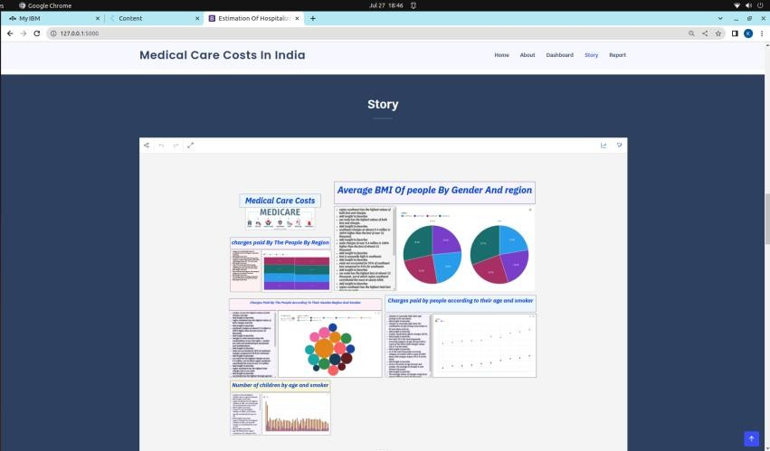
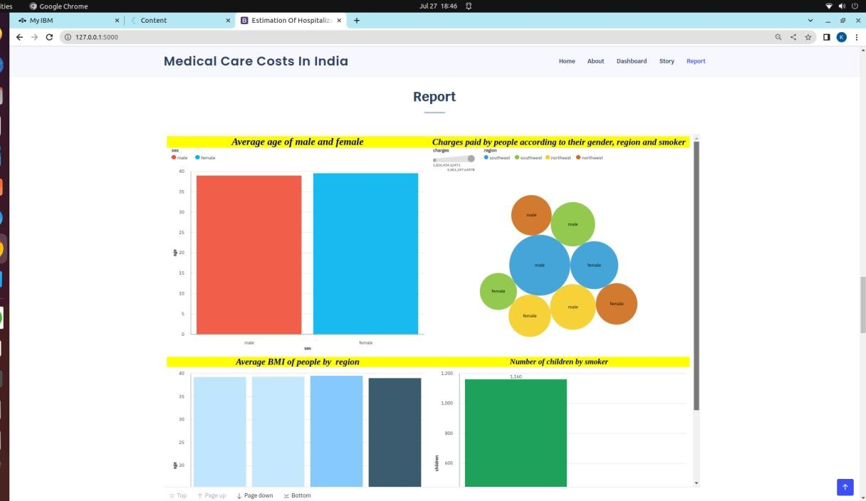
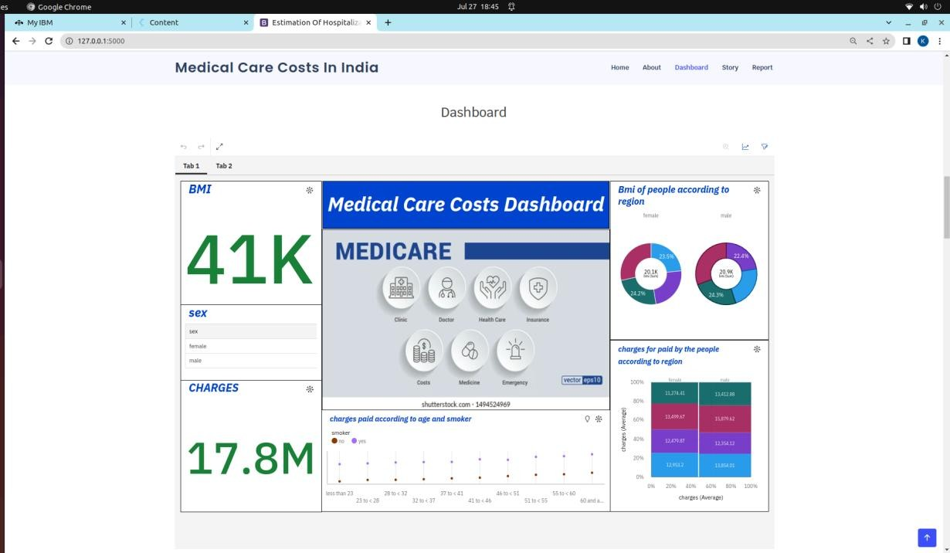

ADVANTAGES:
- Cost Optimization
- Informed Decision-making
- Improved Patient Care
- Tailored Insurance Coverage
- Fraud Detection
- Research and Policy Development

DISADVANTAGES:
  - Data Privacy Concerns
  - Data Quality
  - Model Complexity
  - Limited Predictability
  - Ethical Considerations
  - Overemphasis on Costs

APPLICATIONS:
The Estimation and Prediction of Hospitalization and Medical Care Costs project has several valuable applications in the healthcare industry and beyond.
- Healthcare Cost Management
- Financial Planning
- Insurance Pricing and Coverage
- Resource Allocation
- Treatment Decision Support
- Patient Cost Transparency
- Policy Development
- Fraud Detection
- Benchmarking and Performance
- Research and Public Health
- Cost-Effective Healthcare Programs
- Long-Term Cost Control

CONCLUSION:
In conclusion, the Estimation and Prediction of Hospitalization and Medical Care Costs project holds significant value and potential for the healthcare industry. By leveraging data analytics, exploratory data analysis, the project aims to achieve several important outcomes.

FUTURE SCOPE:
The future scope of the Estimation and Prediction of Hospitalization and Medical Care Costs project is vast
And holds great potential in transforming the healthcare industry.
Overall, the future scope of the Estimation and Prediction of Hospitalization and Medical Care Costs project is dynamic and transformative. As technology continues to evolve and data-driven decision-making becomes increasingly prevalent, the project's applications have the potential to revolutionize healthcare cost management, resource allocation, and patient care on a global scale.

